

Uttaranchal University Canteen Ordering System



Business Analysis Report

Prepared by Riya Singh Rathore

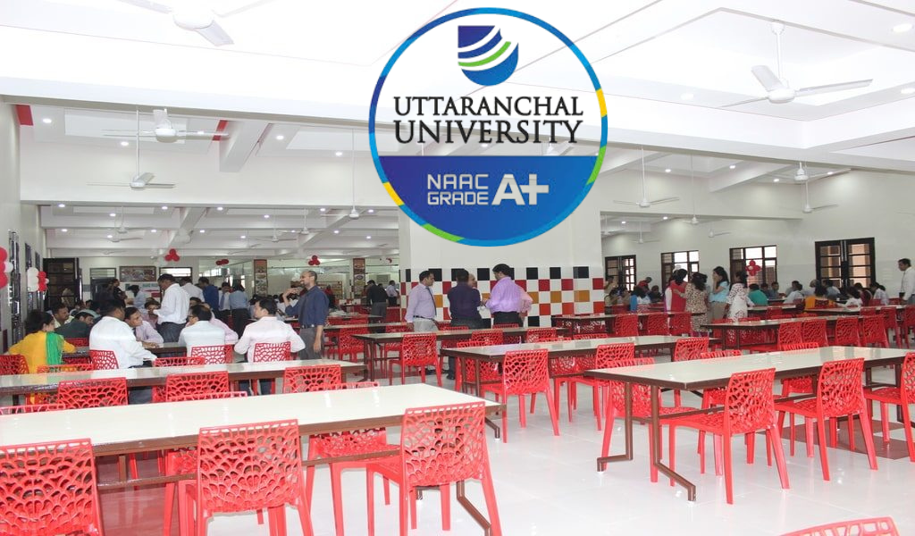

Contents

**Introduction** 2

**Stakeholders Assessment** 2

Stakeholders Matrix 4

**Problem Statement Identified in the Current System** 4

Fishbone Diagram (Ishikawa Diagram) 5

**Objectives of Canteen Ordering System** 5

**Business Analysis Core Concept Model (BACCM)** 6

**Swimlanes of Current (As Is) Process Map** 7

**Swimlanes of Future (To Be) Process Map** 8

**Scope Assessment** 8

**Scope of New Canteen Ordering System** 9

In Scope 10

Out of Scope 10

**Main Features of the Canteen Ordering System** 11

**Activity Diagram with swimlanes** 12

**Database ER diagram (crow's foot)** 13

**Business Requirements Schema** 13

Functional Requirements Analysis 14

Non-functional Requirements Analysis 14

**RACI Matrix** 15

**Mock Screens / Wireframes** 15

1. Log in / Registration Page: 15

2. Menu Page: 16

3. Check-out Page: 16

## **Introduction**

Uttaranchal University is a prominent educational institution with a large number of students and faculty members. The university has a canteen that serves food to students and faculty during lunch hours. However, the current system faces several challenges, including long queues, food wastage, and inefficiencies in managing orders.

Most students and faculty prefer to have their lunch between 12 noon to 1 pm. This leads to a huge rush in the canteen during lunch hours, resulting in students and faculty wasting a lot of time for food to be prepared and waiting for tables to be vacant. Management calculated that it takes around 50 minutes for students and faculty to go and come back from lunch. Almost 25-30 minutes are wasted waiting in a queue to order their food and make payments then wait to collect their food and get a table to sit and eat. However, the time spent eating is barely 10-15 minutes. The remaining 10 minutes are spent reaching and coming back from the canteen.

Students and faculty don’t always get the choice of food they want because the canteen runs out of certain items. The canteen also wastes a significant quantity of food by throwing away what is not purchased.

Many students and faculty have requested a system that would permit canteen users to order meals online, to be picked up at a specified time and enjoy the food without wastage of time.

## **Stakeholders Assessment**

[Access the diagram](https://lucid.app/lucidchart/f2c0a83f-9497-4c02-8072-202283a71586/edit?viewport_loc=-753%2C-386%2C3020%2C1660%2C0_0&invitationId=inv_cdf56893-f542-450b-bfa8-3ee3323e42c1)  
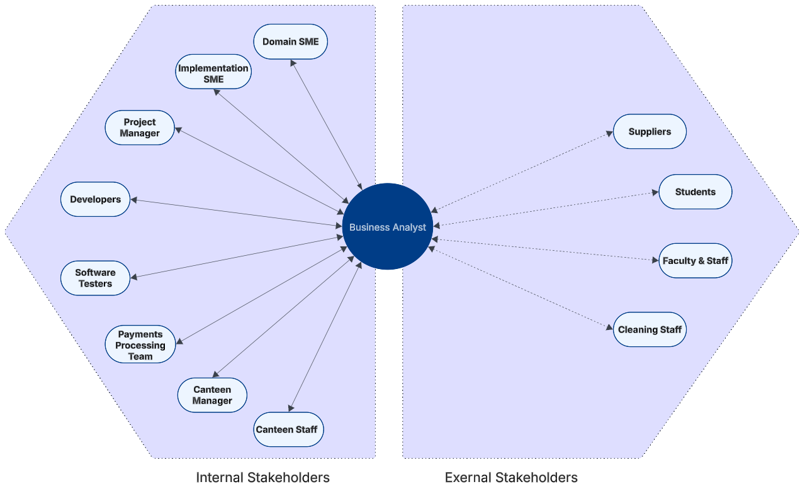

|  |  |
| --- | --- |
| ACTOR | What they can do on the software created? |
| Students | 🔹 The students should be able to open the web & mobile-based Canteen Ordering System to place the lunch order.  🔹 The students should be presented with an up-to-date menu for the day with a list of dishes and its prices.  🔹 The students can select the lunch dishes they would like to eat and create an order for a specific time.  🔹 Once the order is confirmed, they should not be able to cancel or edit the order.  🔹 The order status should be displayed after placing it on the application.  🔹 If a customer does not like any food item, they should be able to submit feedback.  🔹Students can pay using various online methods or in cash also. |
| Faculty & Staff | 🔹 Similar functionalities as students.  🔹 Can order food, track orders, make payments, and give feedback. |
| Canteen Manager | 🔹 Manage and update the menu items and pricing.  🔹 View and process all incoming orders.  🔹 Track daily sales and monitor inventory levels. |
| Canteen Staff (Chefs, Servers) | 🔹 Access pending orders for preparation.  🔹 Update order status (e.g., preparing, order is ready).  🔹 Manage food inventory to ensure availability. |
| IT Support/  Developers | 🔹 Maintain system uptime and ensure smooth operation.  🔹 Troubleshoot technical issues and apply bug fixes.  🔹 Implement software updates and security patches. |
| College Administration | 🔹 Monitor overall system usage and performance.  🔹 Access financial reports and order analytics.  🔹 Approve policy changes and system improvements. |
| Payment Processing Team | 🔹 Manage financial transactions and payment processing.  🔹 Handle refund requests and discrepancies.  🔹 Generate financial reports for budgeting and accountability. |

### Stakeholders Matrix

[Access the Diagram](https://lucid.app/lucidspark/6cec0ca6-599e-4495-aa24-3070ad4190bf/edit?viewport_loc=-2161%2C-1368%2C6167%2C3204%2CgoIk3~KDMGpe&invitationId=inv_24a76107-6feb-4a20-a7f9-ad2e52a225df)

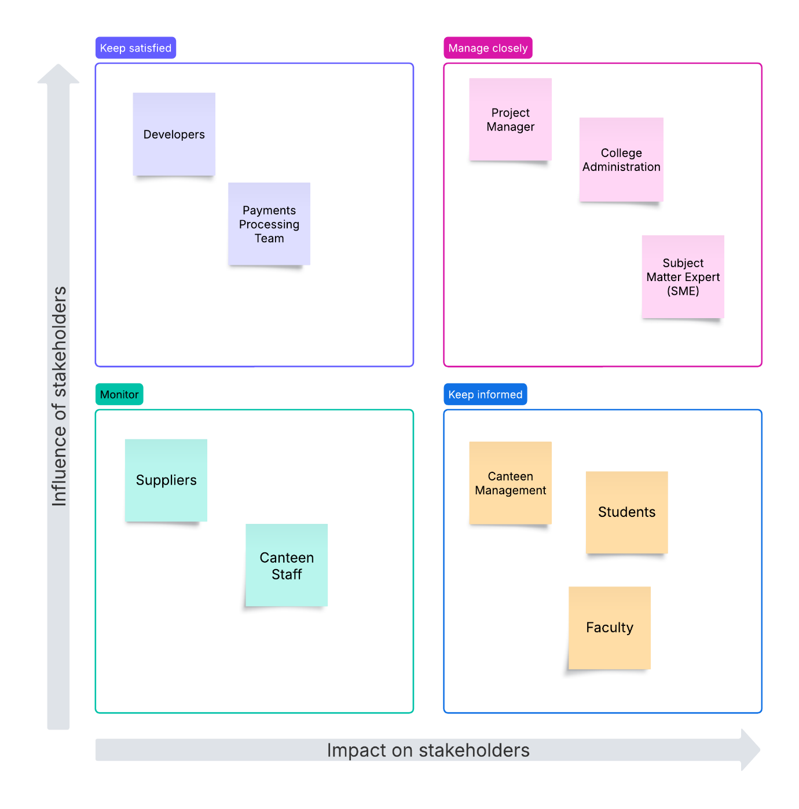

## **Problem Statement Identified in the Current System**

* Uttaranchal University has a large number of students and faculty spread across multiple buildings.
* The canteen serves all students and faculty mostly between 12 PM – 1 PM, causing an enormous rush to get food.
  + 5-10 minutes wasted in queue for ordering food and payment
  + 10-15 minutes wasted in waiting for food to be prepared and finding seats
  + 10-15 minutes spent in eating
  + 10 minutes spent in reaching and coming back from the canteen
  + It took around 50 minutes for student or faculty to go and come back from lunch
* The students and faculty have to wait for long until the food is prepared.
* Limited seating in the canteen results in delays, affecting the time available for students and faculty.
* Students and faculty complain that they do not get the food they want due to shortages.
* Food wastage is noted due to over-ordering and inventory shortages.
* High operational costs are recorded due to inefficiencies in the current system.

### Fishbone Diagram (Ishikawa Diagram)

[Access the diagram](https://lucid.app/lucidchart/f2c0a83f-9497-4c02-8072-202283a71586/edit?viewport_loc=-753%2C-386%2C3020%2C1660%2C0_0&invitationId=inv_cdf56893-f542-450b-bfa8-3ee3323e42c1)

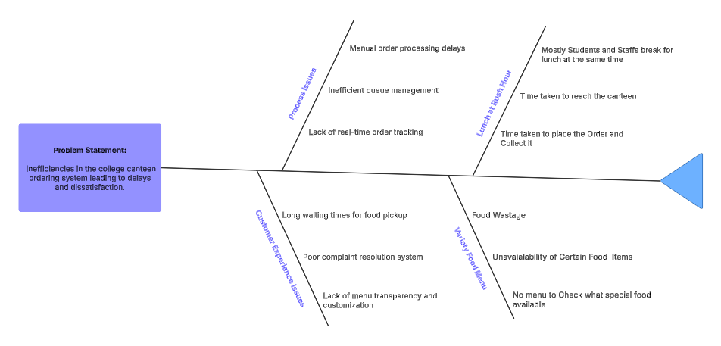

## **Objectives of Canteen Ordering System**

**Objective- 1&2 (Canteen Operations)**

1. Reduce canteen wastage by 30% within 6 months.
2. Reduce canteen operating costs by 15% within 12 months by working with key suppliers, controlling inventory, and minimizing food wastage.

**Objective- 3 (Work Efficiency)**

1. Increase productivity by reducing wait times and improving seating arrangements by 30 minutes within 3 months.

**Objective-4 &5 (Online System)**

1. Make Ordering process automated
2. Operate the canteen with fewer manpower resources.

## **Business Analysis Core Concept Model (BACCM)**

|  |  |
| --- | --- |
| Concepts | Description |
| Change | **Key Question:** What modifications need to be made to enhance the ordering experience?  🔹 The transition from a **manual** canteen ordering process to a **digital** pre-order system. 🔹 Adoption of an online system for **ordering, payment, and tracking order status**. 🔹 Training for staff and students to use the new system effectively. |
| Need | **Key Question:** What business problems does the new system solve?  🔹 Long waiting times and inefficiencies in the traditional ordering process. 🔹 Frequent mismanagement of inventory and food supply. 🔹 Lack of **transparency** in order status and payment options. |
| Solution | **Key Question:** What solutions address the identified needs?  🔹 A **web & mobile-based canteen ordering system** for pre-ordering meals. 🔹 Integration of **cashless payments** and real-time order status tracking. 🔹 **Automated inventory management** to prevent shortages and food waste. |
| Stakeholder | **Key Question:** Who will be affected by the changes?  🔹 **Internal Stakeholders:**   * Canteen Management and Staff (order processing) * IT Developers (system design) * College Administration (policy and funding) * Payment Gateway Providers * Subject Matter Expert (SME) * Project Manager   🔹 **External Stakeholders:**   * Students (end-users) * Faculty & Staff (users) * Suppliers (food and raw materials) |
| Value | **Key Question:** What value does this system provide to stakeholders?  🔹 Reduced waiting time and **improved customer satisfaction**. 🔹 **Operational efficiency** for canteen staff and suppliers. 🔹 **Data-driven decision-making** for inventory and supply chain management. 🔹 Increased **revenue and profitability** due to better demand forecasting. |
| Context | **Key Question:** What external factors influence the implementation of the solution?  🔹 The solution must align with **college policies, budget, and infrastructure**. 🔹 **User accessibility** (mobile and desktop compatibility). 🔹 Ensuring **data security** and privacy compliance. |

## **Swim-lanes of Current (As Is) Process Map**

The As-Is Process of the college canteen ordering system highlights inefficiencies such as long queues, food wastage, and limited menu options. Students and faculty manually place orders at the canteen during peak hours, leading to delays and dissatisfaction. The lack of a preordering system results in over-ordering or shortages, causing food wastage and inventory mismanagement. Additionally, the canteen staff struggles to manage high demand, and the manual process lacks real-time updates, leading to inefficiencies in food preparation and distribution.

[Access the diagram](https://lucid.app/lucidchart/8f2154d5-7812-4498-88bd-0e6ee7e97153/edit?viewport_loc=871%2C-574%2C4257%2C2193%2Cm-5o7ONTd-nK&invitationId=inv_bd23b2ef-b520-4c60-a5f3-36a8b22234b3)

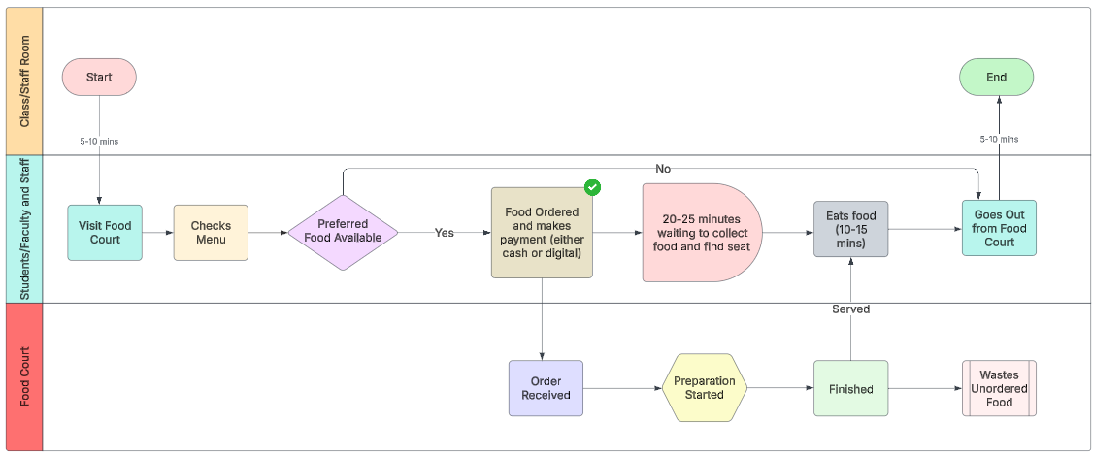

## **Swim-lanes of Future (To Be) Process Map**

The **To-Be Process** introduces an online canteen ordering system that streamlines operations. Students and faculty can preorder meals via a user-friendly platform, selecting from an updated menu with real-time availability. It allows the canteen to prepare meals efficiently and reduce food wastage. A payment gateway supports both online and cash payments, enhancing convenience. The system includes a pick-up option, where users collect their orders at designated times, eliminating long queues. Feedback mechanisms allow users to rate food quality and service, providing valuable insights for improvement.

The To-Be process reduces operational costs, improves user satisfaction, and increases productivity by minimizing wait times and optimizing resource allocation. Overall, the new system transforms the canteen experience, making it efficient, user-friendly, and sustainable.

[Access the diagram](https://lucid.app/lucidchart/3b183944-0fb4-4e3b-b9ac-91ceb147243f/edit?viewport_loc=-2250%2C-1280%2C5058%2C2606%2C0_0&invitationId=inv_ca918077-973a-47e4-afa6-38412a6007ef)

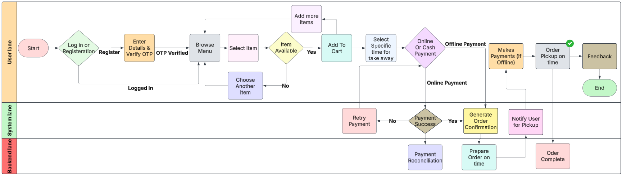

## **Scope Assessment**

Context diagram gives a bird's eye view on the entire system and the data flows within. It shows how each section acts and how they transform data which they receive as input and give out as output for the next section or process point to carry out.

Online canteen acts as a centre hub for all the data to flow and transform into their respective forms and flow into the next sector. Even when this is a loop, the centre acts as a storage (mostly temporary) the initial trigger comes with the input from the user side which triggers other entities even when it comes to the report generation at the end of each month (continuous process for continuous improvement and monitoring). By centralizing data flow and transformation, the online canteen system enhances operational efficiency, reduces errors, and improves user satisfaction. This continuous loop of data flow and transformation ensures the system evolves to meet changing demands and maintains high performance.

[Access the diagram](https://lucid.app/lucidchart/88eb540f-ab4b-4530-b417-a67e38d1c258/edit?viewport_loc=-342%2C57%2C1968%2C837%2C0_0&invitationId=inv_81518e9e-7a58-4a94-9225-55bbc2f87b66)

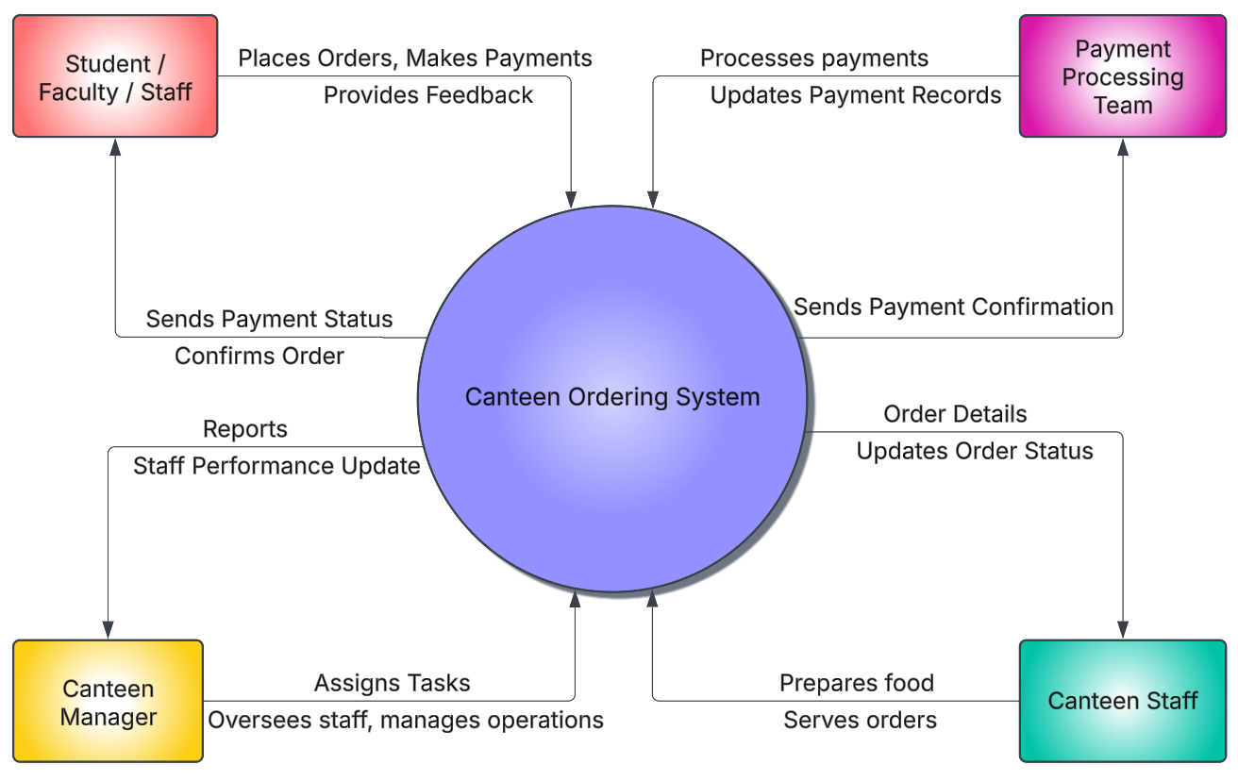

## **Scope of New Canteen Ordering System**

The requirement states that Uttaranchal University management needs a canteen ordering system in place that allows students and faculty to get the desired food prepared on time so that they come and pick up their orders. The proposed system includes the following:

1. Students and faculty can register using their mobile number or university ERP ID. After registration, they become existing users with an account to place online orders.
2. Lunch orders must be placed 20 minutes before so that it can be prepared on time.
3. Orders can be altered before the order confirmation process ONLY.
4. The canteen manager updates the menu daily to provide student and faculty favourites and new items.
5. The canteen manager assigns the canteen staff to orders and ensures they are prepared on time.
6. The canteen staff marks the order as ‘completed’ after successful pick-up by the respective person.
7. Students and faculty submit feedback through a survey form to provide analytical information to the university management.
8. Students and faculty can make payments online or in cash.
9. The university will save on operational costs, reduce wastage, and increase productivity by using the dedicated Canteen Ordering System.
10. Management would like to have records of the following reports:
    * Most popular item from the menu.
    * Number of users/students and faculty using the COS.
    * Level of satisfaction of users who are using the COS.
    * Sales each day from the canteen.
    * Order forecasting.
    * Feedback from students and faculty.

| In Scope | Out of Scope |
| --- | --- |
| Students and faculty can register using their university credentials. Login functionality for existing users. | Recommended or Suggested food items to place orders quickly. |
| Canteen manager can update the daily menu with pricing and availability. Students and faculty can view the updated menu. | Canteen staff management webpage for Canteen Manager |
| Order must be placed 20 minutes before the pick-up time. Users can select items from the menu and confirm their orders. | No delivery option is available. Users must pick up their orders from the canteen. |
| Users can choose a pick-up time slot. Orders are prepared and ready for pick-up at the designated time. | The system does not provide personalized menu recommendations based on user preferences. |
| Both Payment gateway (Online or in Cash). Online payment options (e.g., credit/debit cards, net banking). Cash payment option for users who prefer to pay at the canteen. | The system does not track real-time inventory levels for ingredients. |
| No cancellation or edit after the order is placed | Refund option is not available |
| Canteen Manager to check inventory and send orders to the Chef |  |
| Canteen Staff to complete the order after pick-up |  |
| Feedback form if the user is not happy with the food |  |
| Payment processing team to have records/history of orders from each user for payment reconciliation |  |
| Management would like analytics based on feedback and orders such as:  - Most popular dish  - Number of users using the canteen ordering system  - Feedback to result in how many users are satisfied with the COS  - Order forecasting |  |

## **Main Features of the Canteen Ordering System**

1. Specifically designed webpage where students and faculty can register with their university ERP ID and log in using their credentials to place online orders.
2. The COS will be available only for students and faculty who are on campus.
3. After login, users will be able to view the updated menu from the new COS, where they can order their favourites and check the pricing of each item.
4. After selecting the items from the menu, users can confirm the total amount/value of the order, choose the specific time, make payments (online or in cash) and confirm the order via OTP.
5. Canteen managers should be able to view the order and items within the order number and communicate the same with the Chef. The canteen manager will assist Canteen staff who will ensure the meals are picked up by users on time.
6. After pick up, the Canteen staff should be able to close the order via mobile phone or webpage.
7. Post-pick up, a feedback form should be triggered to all users’ email addresses regarding the meals they have ordered.
8. The feedback form should provide university management with several reports based on the orders, taste and quality of food, most ordered dishes, order forecasting, user satisfaction levels, and the number of users using the COS.
9. Users receive real-time notifications via SMS or email for order confirmation, pick-up reminders, and any changes in menu availability. Canteen staff and managers also receive notifications for new orders, cancellations, or updates.
10. Users can view a list of most popular dishes based on real-time data (e.g., most ordered items in the past week or month). Popular dishes can be highlighted on the menu or displayed in a separate section for easy access.
11. Users can search for specific dishes using a search bar. Search results display relevant dishes with pricing, availability, and user ratings.

## **Activity Diagram with swim-lanes**

[Access the diagram](https://lucid.app/lucidchart/8d3c1401-4083-41eb-9608-2fbb3a687af0/edit?viewport_loc=-2029%2C-1016%2C5441%2C2314%2C0_0&invitationId=inv_10eda995-7e52-438e-b9c0-42234a17e4c1)

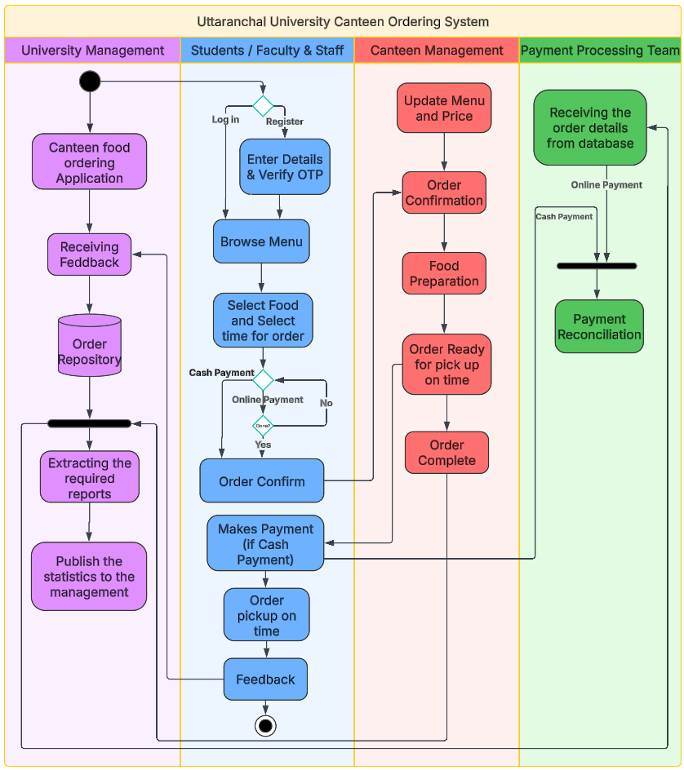

## **Database ER diagram (crow's foot)**

[Access the diagram](https://lucid.app/lucidchart/c0694c34-a96e-4af9-88bb-0f725cfe8a61/edit?viewport_loc=817%2C-208%2C1868%2C795%2C0_0&invitationId=inv_1182af6f-981d-46f1-a8e5-b0c58504f885)

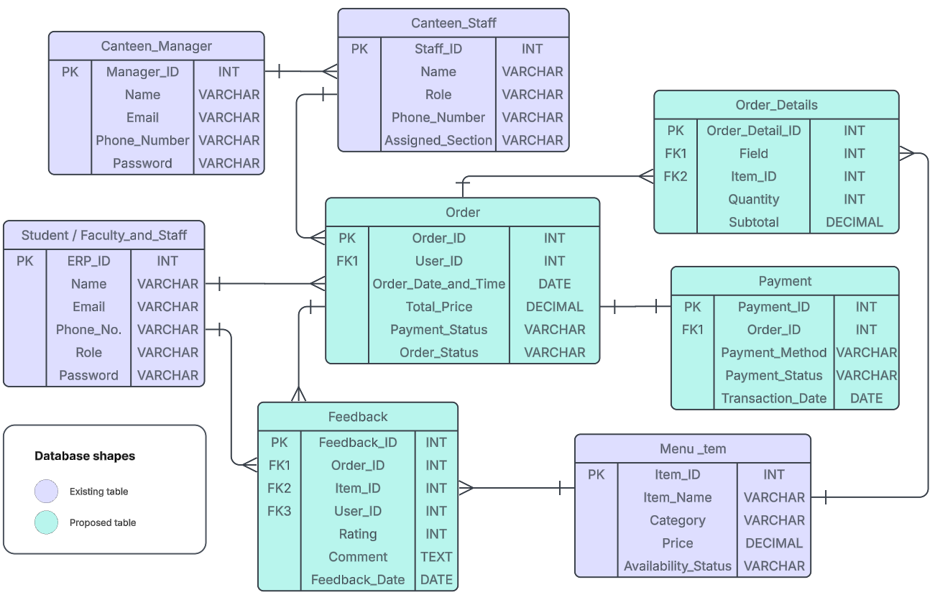

## **Business Requirements Schema**

[Access the diagram](https://lucid.app/lucidchart/e180d79b-69eb-40e3-b0c0-c2360b06c7a9/edit?invitationId=inv_fcab688d-eaf2-45d8-9de5-eb206296b93b)

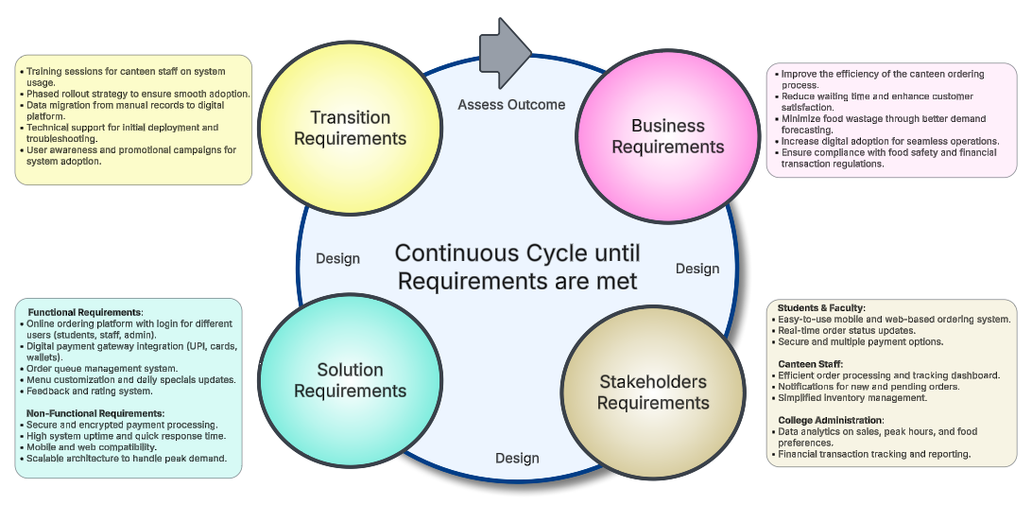

### Functional Requirements Analysis

* All end users (students and faculty) to have a login page of the Canteen Ordering System (COS).
* Canteen Manager to update the menu daily from an admin login page.
* Lunch orders to be placed 20 minutes before the pick-up time.
* Once a lunch order is placed, users will not be allowed to cancel or make changes to the existing order.
* The Canteen staff will have to close or ‘mark’ the order as ‘completed’ after pick-up of order on specified time.
* Users can provide optional feedback depending on the quality and taste of the canteen food.
* Management will have the accessibility to view the following reports generated from the Canteen Ordering System:
* Most popular dish
* Number of users using the system
* User satisfaction feedback or complaints
* Daily sales/revenue report
* Order forecasting report

### Non-functional Requirements Analysis

* **Scalability and Performance**: Scalable for a large number of users at a time. Performance based on the capabilities of the Canteen Manager, Chef and Canteen Staff.
* **Availability**: COS webpage should be fast and lightweight. It should be accessible from mobile or laptop also.
* **Usability**: User-friendly and self-explanatory ordering concept.
* **Maintenance**: Software development made in Java language.
* **Accuracy**: Reports generated from the COS should be based on input from the Canteen Manager and end users.
* **Security**: The system to be secured with ERP ID and password of the end user. Every time user has to enter captcha to login securely. If the user is login through mobile number, he must submit the OTP send to their number.

## **RACI Matrix**

[Access the diagram](https://www.figma.com/board/PMm0UOVaYuDLQZdELqbFed/Untitled?node-id=0-1&t=wTg89DunkNy6kKjU-1)

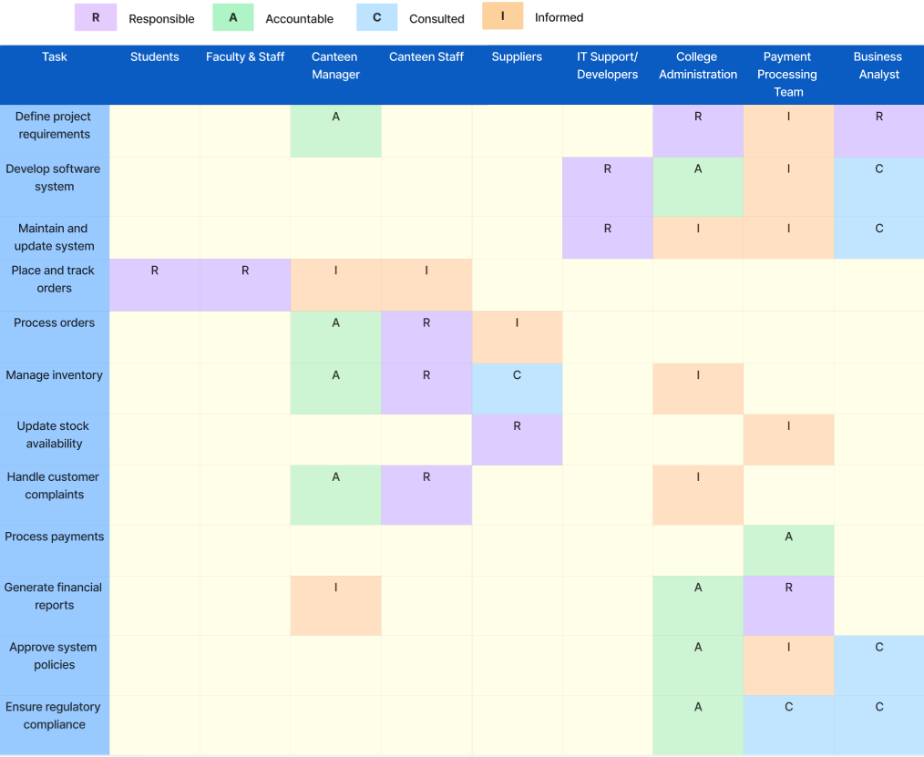

## **Mock Screens / Wireframes**

[Access the wireframe](https://balsamiq.cloud/svtjvsp/pq2qpvs)

### 1. Log in / Registration Page:

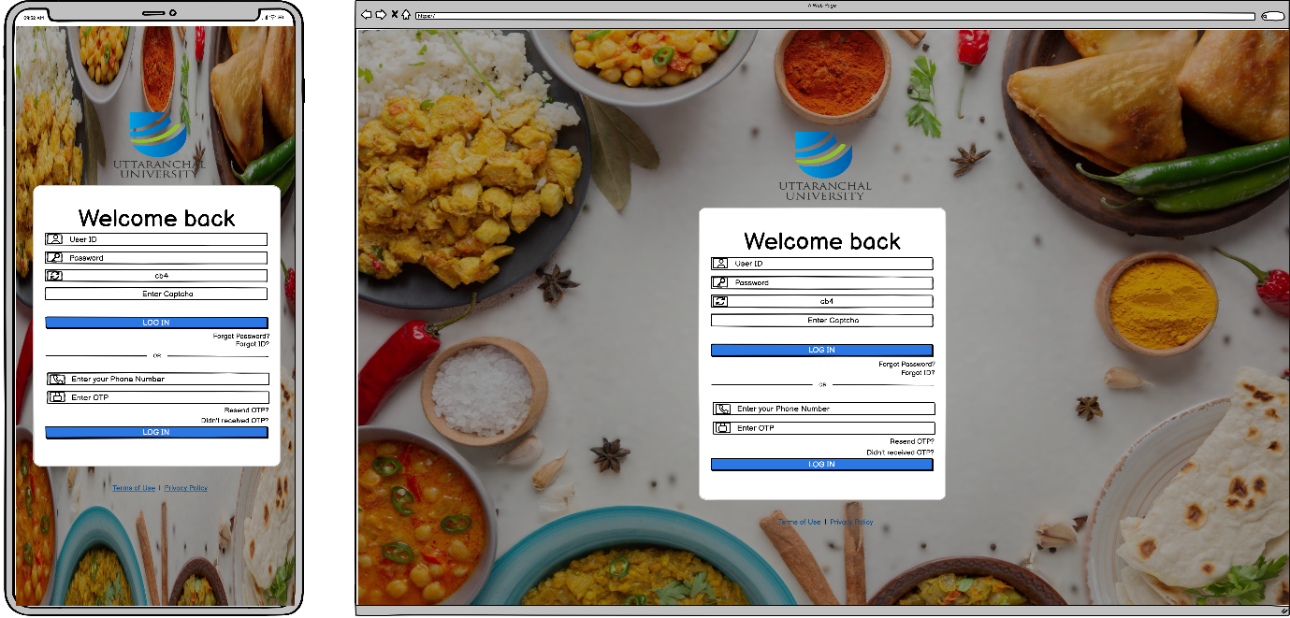

### 2. Menu Page:

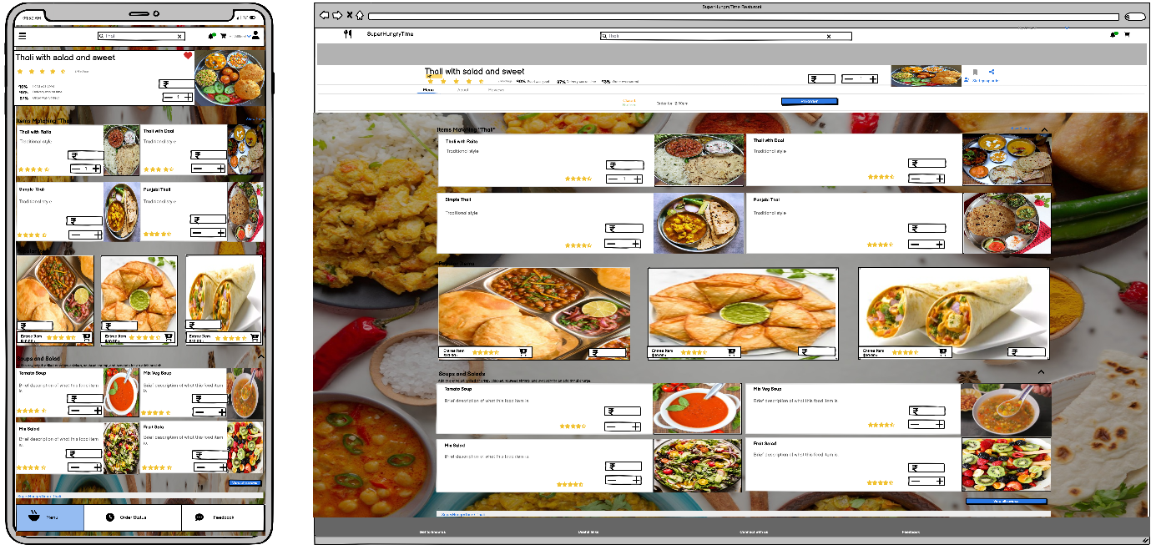

### 3. Check-out Page:

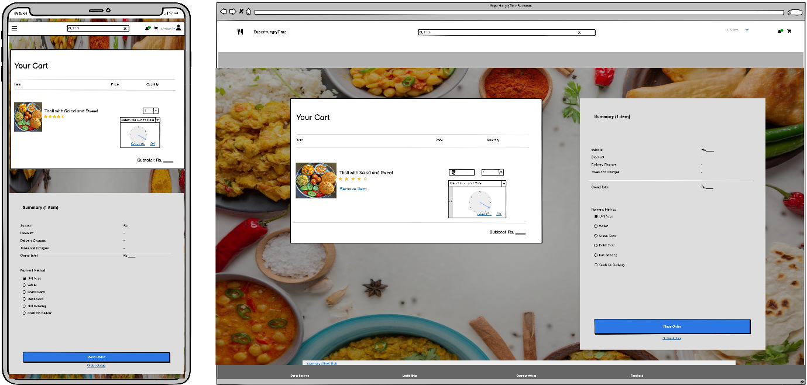

Thank You!!